Lab 3
3.1 Write a program to find out the GCD by using methods.

Source Code
class Calculator():

def calc_factors(self, gcd):
a = input("Enter first number: ")
b = input("Enter second number: ")
a = int(a)
b = int(b)
arr = []

while a != 1 or b != 1:

if a % 2 == 0 and b % 2 == 0:
a = a / 2
b = b / 2
arr.append(2)

elif a % 3 == 0 and b % 3 == 0:
a = a / 3
b = b / 3
arr.append(3)

elif a % 5 == 0 and b % 5 == 0:
a = a / 5
b = b / 5
arr.append(5)

elif a % 2 == 0:
a = a / 2

elif a % 3 == 0:
a = a / 3

elif a % 5 == 0:
a = a / 5

elif b % 2 == 0:
b = b / 2

elif b % 3 == 0:
b = b / 3

elif b % 5 == 0:
b = b / 5

for x in arr:
gcd = gcd * x
self.gcd = gcd

def display(self):
print("The GCD is: ", self.gcd)

nabeel = Calculator()

nabeel.calc_factors(1)
nabeel.display()

Output

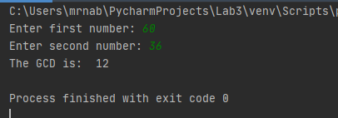

3.2 Write a program to reverse a string word by word by using parameterized constructor.
Source Code
class word:
def __init__(self, b):
a = b
print("The reversed word is:", a[::-1])

b = (input("Enter any word : "))
b = str(b)
word(b)

Output
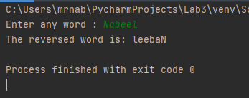

3.3 write a program to find ASCII Value of a Character by using parameterized constructor.
Source Code
class convert():
def __init__(self, num1):
a = num1
a = ord(a)
print("The reversed value is ", a)

num1 = input("Enter the Character: ")
convert(num1)

Output
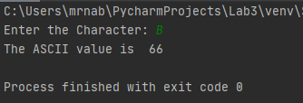

3.4 write a program to find the maximum numbers between 10 numbers by using methods.
Source Code
class nabeel:
def find(self):
print("Enter ten numbers: ")
arr = []

for x in range(0, 9):
num = int(input())
arr.append(num)

greatest = 1

for y in arr:
if y > greatest:
greatest = y

print("The greatest value is ", greatest)

rizwan = nabeel
rizwan.find()

Output
